March 26th, 2006
Hi
Not that much to write about this time. Leonie arrived Friday afternoon but then went straight to the hostel at the Prince of Wales Hospital. She is quite happy with the room she has; very comfortable and even has a sink for washing. Yesterday morning she came here for the day and for overnight. Spent some time on the computer and printing things. Later in the afternoon, jet lag set in and she flaked out on the bed. In the evening, she went to town.
Last Monday I went to the clinic again for another biopsy on a pink patch on my upper chest. This one hurt a bit more than the previous two. However, there was no bleeding afterwards as there had been for the others. In fact, I still have the covering on it. But to keep water off it, I have not been able to have showers. So, each day after gym, I would return and then have a bath avoiding getting the would wet. But it should be OK now. Went to the gym normally this time. On Wednesday, got a call from the Tuen Mun Hospital to tell me that the date for my consultation (operation?) has been advanced to April 6th. That’s a bit better than having to wait until January on next year. I also have another appointment on April 3rd to get the stitches removed from the present wound. (Gavin, that means there will be less time to see you, considering you are only here for 4 days.)
For a few days this past week, I also had a cold and a sore throat. All gone now though. No idea how it happened.
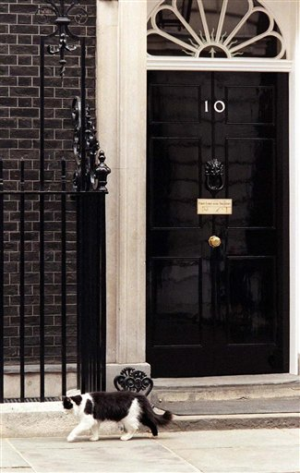
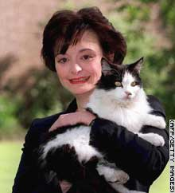
Did you hear that Humphrey (1988 – 2006), the Downing Street cat, died this past week? Saw quite a bit of it on TV! The cat, which was a stray, wandered into the residence many years ago when Margaret Thatcher was Prime Minister so she kept it. Her successor, John Major, also allowed it to stay. However, when Tony Blair moved in, apparently his wife evicted it, as she doesn’t like cats (in spite of the smiles in the photo on the left). There was an outcry over this but the cat was OK, having been adopted by someone in Blair’s government. Apparently, Humphrey is something of a survivor; once he narrowly avoided death when he was nearly run over by U.S. President Bill Clinton's two-ton bulletproof Cadillac!
That’s about it for now.

Cheers.

